Karen Sweeney
Assignment 6-1
Slavery has been around for thousands of years. The Book of Genesis depicts several cases of slavery including Abraham and Sarah owning slaves, naming Hagar in particular. Joseph, the son of Jacob, was sold into slavery by his brothers. In the Book of Exodus, we see the Israelites were forced into slavery by the Egyptians. In the New Testament, which was in the Greco-Roman era, slavery was prevalent throughout the Roman Empire and beyond.
Slaves served many different functions and served in different roles. Slave work included working in the mines, which was backbreaking and in harsh conditions. Many slaves died in the mines while their owners reaped great profits. Slaves worked in the fields planting and reaping crops, while others worked in construction. There were domestic slaves that worked in households as cooks, cleaners, and caretakers to children. Skilled labor included accountants, teachers, and even physicians. Some slaves worked in public service as administrators, secretaries, and accountants, while others worked as entertainers such as musicians, actors, performers, and even gladiators.
Many people became slaves as captives of war, but others were forced into slavery by the capture of pirates. Human trafficking was legal and a profitable business. Poor and desperate parents often sold their children into slavery and women slaves who bore children, those children were slaves as well. Other slaves sold themselves or were forced into slavery due to criminal activity. Slaves came from many different territories such as Ireland, Scotland, the Black Sea area, the Arabian Peninsula, Africa, some of the eastern European areas, along with the borders of the Roman Empire.
Early Roman culture had no feelings of injustice or inequality, but slavery was seen as a fact of life. There were citizens who spoke against the mistreatment of slaves and there were a few revolts recorded but there was never an abolitionist movement. Slaves and all their possessions were owned by their master. They had no rights and could be treated as the master saw fit. Master could inflict severe punishment and could even kill their slaves without repercussion. Masters could sell their slaves to others if they wished. The domestic and educated slaves were generally treated better due to their positions.
Masters would hand down slaves to their children but could also be set free or pay for their freedom. Many slaves were obedient and hardworking in the hope of being freed. Once free, slaves could continue to work the same job for pay and it gave them the possibility to become Roman citizens, but they were always left with the stigma of being a slave. Once they became Roman citizens, it allowed them to purchase land and have other rights.

During the New Testament, Paul is telling slaves to obey their masters with a good attitude and telling masters to treat their slaves well, reminding them that they have a master in Heaven. In doing this, Paul does not endorse slavery but is seeking to improve the situation and the conditions of the slaves. He talked about mutual love for another even in the challenge of inequality.

Karen Sweeney
Assignment 6-2

The Book of Haggai was written about 520BC. Haggai was a minor prophet who delivered a message to Israelites who returned from being exiled in Babylonia for 70 years. The theme was that the Temple of the Lord, which was destroyed in 586BC had come to a standstill, while the Israelites continued to build their own houses.

The Persian ruler Cyrus the Great had let the Israelites return to Jerusalem under the leadership of the High Priest named Joshua and to Zerubbabel, and descendant from the line of King David, to rebuild the Temple. This was about 539BC to 538BC, and they were committed at first but soon received opposition from the Samaritans and other groups of people. This opposition caused the Israelites to stop the construction of the Temple. Haggai was sent to emphasize the importance of rebuilding the Temple and restoring proper worship. He is letting them know that their priorities are misplaced, instead of rebuilding the Temple they have put their time in effort into building their own homes and this is why they are experiencing famine and drought.

Haggai then returns one month later to see progress of the Temple but not much has been done and the Israelites still lack ambition. He reminds and encourages the Israelites of God’s prophetic promises and the future Kingdom of God, drawing from previous prophets like Micah and Isaiah. This encourages Joshua, the high priest, and Zerubbabel to gather the people together to complete the work on the Temple.

Haggai then returns two months later and reminds the Israelites of the covenant with God and how they must humble themselves, repent of their sins, and turn away from injustice. He the concludes with the future hope in God’s Kingdom if they are faithful and obedient.

Assignment 6-3
Laodicea List
- Laodicea brought its water through a six-mile-long aqueduct from the hot springs of Hierapolis and the cool water from Colosse. The hot water became cooled in the aqueduct and the cool water warmed up making the water from either place lukewarm.

- It had a famous school of medicine contributing to advancements in medical technology.

- The popular Phrygian ointment, used to treat eye defects, was either manufactured or distributed there.

- There was a temple for their god of healing (Men Karou) and their supreme god Zues.

- The great Roman road ran through its center, making Laodicea an important center for trade and communication.

- Had other trade routes making it easy to get to other major cities, such as Smyrna and Ephesus.

- It was a center for textile production and banking.

- It was one of the cities in the fertile Lycus Vally.

- Its wealth also came from the production of black wool.

- After the earthquake of 17AD, Laodicea refused imperial help in rebuilding, choosing to it by themselves.

- It was a city where people learned to compromise and accommodate the will of others to make money.

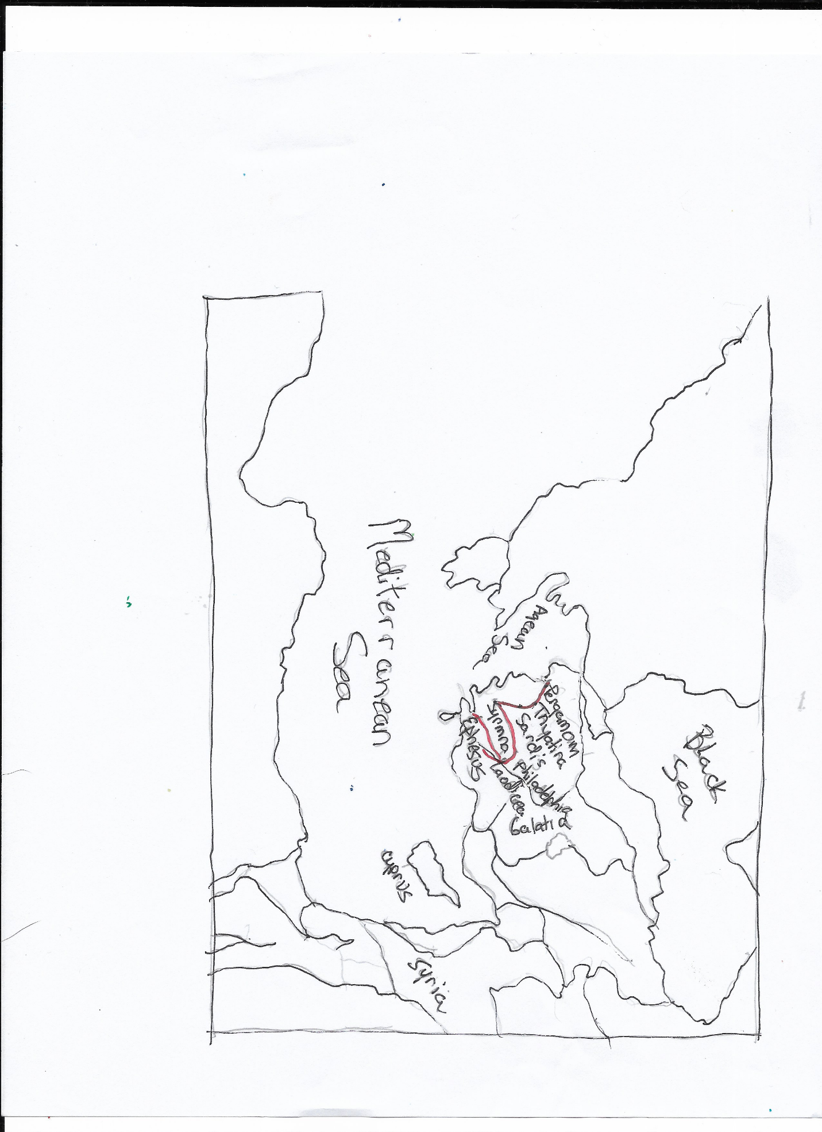
Assignment 6-4
Samaritans
- Samaritans identified with the ancient Israelite heritage, but their religious views and practices differed from the Jews.

- Jews and Samaritans were often hostile toward one another, especially after the Babylonian exile when the Jews returned to Jerusalem to rebuild the Temple and would not let the Samaritans help with the rebuilding.

- Jews thought Samaritans as “unpure”, and contact would “defile them”.

- Jews thought only the Jerusalem Temple was the proper center of worship while the Samaritans worshipped at the Temple on Mount Gerizim, where Jacob’s well lies at the bottom of the mountain.

- Samaritans only used the first 5 books of the Bible called the Torah or Pentateuch.

- Samaritans followed the Levite priests as their religious authority but also included foreign deities, but the Jews looked to rabbis for the interpretation of the Law, who also deviated from the original content.

- Many Jews would not travel through Samaria to get to Jerusalem, even though it was the shortest route.

- No Jewish rabbi would speak to a Samaritan woman, or drink from a Samaritan’s cup.

- When Jesus talks with the Samaritan woman about the “living water” the woman does not understand at first. Jesus replies that the material water that she is getting from the well will only satisfy her thirst temporarily but the “living water” (Holy Spirit) would come from within. Jesus is trying to elevate her way of thinking and when he talks about her past, she seems to realize that he may be a prophet or more. She then raises the issue about worship and when Jesus tells her true worship is that of the spirit and that “God is spirit” and that one can worship anywhere it gives her hope. He then lets her know that he is the messiah and she believes and takes her new knowledge to tell the other villagers.

- Note that the woman and her village accepted Jesus as the Messiah, but the Jewish leaders did not.

Assignment 6-5

Nehemiah

Kislev to Nisan

In Nehemiah, the amount of time between the month of Kislev (Chislev) and the month of Nisan is approximately 4 months. Kislev is between November/December and Nisan is between March/April of the following year.

Susa

Susa is in Southwestern Iran which was formerly Persia. It lies near the foot of the Zagros Mountains near the Karkheh and Dez Rivers in the Khuzestan Province. It was part of the Persian Empire and was the administrative capital during the reign of Darius I, Xerxes I (Ahasuerus), and Artaxerxes (Xerxes’ son). Susa was formerly part of the kingdom of Elam.

Queen Esther was the wife of the Persian ruler Xerxes I, who ruled in about 485-465BC in Susa. Mordecai was the uncle who raised Esther and after she became queen, rallied for her to speak to her husband in saving the Jewish people from the edict that Haman persuaded King Xerxes to sign under false pretense to eradicate the Jews. Queen Esther succeeded in saving her people.

During the reign of Artaxerxes, Nehemiah goes to Jerusalem in about 444BC to aid in the rebuilding of the walls and fortifying the city. He discussed the importance of putting God first, keeping the Sabbath, and not marrying foreigners as they might turn them away from God.

King Artaxerxes and the cupbearer’s status

King Artaxerxes ruler in 465-424BC of the Achaemenid Persian Empire and was the son of King Xerxes I. Nehemiah was his cupbearer which was a high ranking official and a coveted position that protects the king by tasting his wine for any poison but also is a trusted advisor. The king and cupbearer often had a very close relationship and the king relied on the cupbearer’s knowledge of wines and what was going on in royal court.

